In the below guide, Lactate will be discussed, despite the thresholds being determined only through the means of analysing gas exchange variables. This is only to provide further context around the phases that precede and follow each of the two thresholds.
Determining Threshold 1 - The Gas Exchange Threshold (GET)
Considerations when identifying
- In the phase preceding this threshold, lactate has started being produced, but production does not exceed the rate of clearance. VO2, VCO2 and VE will continue to augment linearly until the GET.
Threshold identification
- The GET itself is the point immediately preceding the onset of metabolic acidosis. After the GET, the contribution of anaerobic metabolism to energy production increases so that lactate production exceeds the rate of clearance. Shifts in gas exchange variables can be observed, whereby VCO2 and VE begin to escalate disproportionately to VO2 and workload. Therefore, the ventilatory equivalent for VO2 (eqO2) increases, indicating reduced efficiency. The ventilatory equivalent for VCO2 (eqCO2) remains stable as VE and VCO2 increase proportionally to one another.
Primary Criteria
- Increase in PetO2 WITHOUT a decrease in PetCO2 (remains relatively stable)
- Increase in EqO2 while EqCO2 remains stable
Verification Criteria
- RER of ≤ 1, usually 0.80-1.0
- Break point in the V-slope, VE and VCO2 trajectory
Application to exercise
- Exercise intensities between the GET workload and RCP workload can typically be continued for 20mins plus. This duration will vary significantly depending on how trained the individual is and if the workload is closer to that identified at the GET or RCP. Despite fatiguing by-products beginning to accumulate when exercising at workloads between the GET and RCP, this is not at a level that is detrimental to being able to continue exercise. The further beyond the RCP one goes, the more fatiguing by-products that will accumulate and exercise can only be continued for a short amount of time.

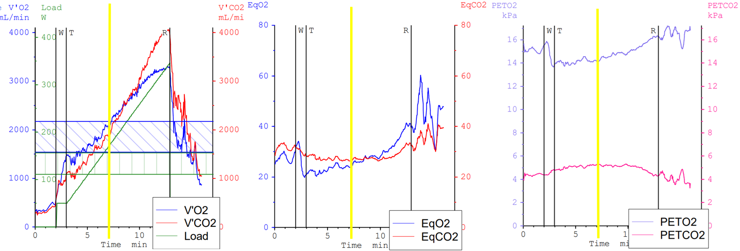
EXAMPLE
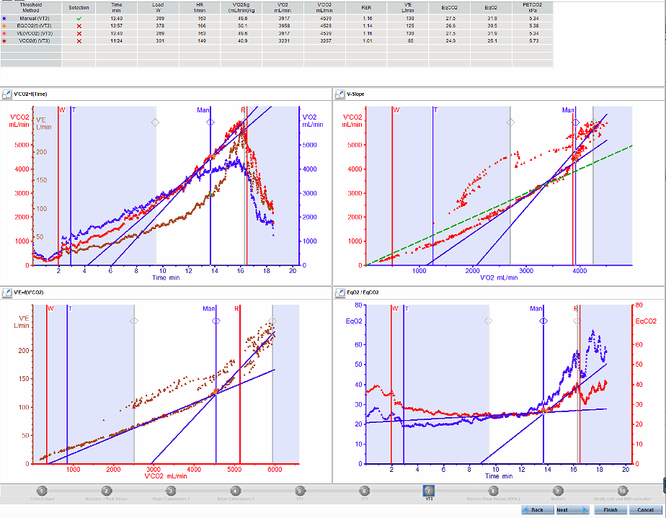
Note - Determining the RCP is utilised to then determine the gradient of the VE/VCO2 slope.
Determining Threshold 2 - The Respiratory Compensation Point (RCP)
Considerations when identifying
- In the phase prior to the RCP, it is likely that the maximum lactate steady state (MLSS) will be reached and exercise intensity will only be able to be maintained for a short amount of time. Reliance on anaerobic metabolism progresses and so too does the accumulation of lactate in venous blood supply.
RCP identification
- Towards the end of a maximal exercise test the RCP can be identified where VE displays a further disproportionate increase relative to VCO2. Despite the increase in ventilation, VCO2 and VO2 does not match this increase, which is reflected by the increase in the EqCo2. Ventilation increases so much so that the PetCO2 begins to drop thus representing an “overcompensation”.
How to relate this to a CPET
- Once the RCP is surpassed, exercise can only be continued for a short amount of time when intensity continues to increase incrementally. This is often around 2-4minutes give or take but can vary considerably due to factors such as how close to a max test it was and fitness levels. Ventilation will continue to increase disproportionately until the point of maximal oxygen uptake. Ideally a plateau in VO2 will be observed.
Primary Criteria
- Increase in EqCO2 and EqO2 at a faster rate, and decrease in PetCO2
Verification criteria
- Increase in VE at a faster rate, which is disproportionate to the increase in VCO2 and VO2
- Increase in the VE/VCO2 slope
- RER >1

Determining the VE/VCO2 slope
This is the gradient of VE plotted over VCO2 and includes from the start of the exercise test up until the RCP. The warmup should be excluded unless the test is very short and cannot be analysed without it.

